Logistic regression

We will represent an email as a vector of word counts (number of occurrences of every word) with a length of V (which will be the vocabulary, every unique word in the email):
For instance, if our vocabulary is 3 words, and we test an email that has 2 of those words:
Word | Count
free | 3
money | 1
meeting | 0

So:
$$email= \left[3,1,0\right]$$

In order to actually calculate a score, we will say:
$$z \left(score\right)= W_{free}×3+W_{money}×1+W_{meeting}×0+b$$

Or in other words:
$$z=w×x+b$$

Where b is “bias”. Bias helps adjust imbalanced training dataset, for instance, if the dataset has more ham emails than spam, then the model by default would already lean towards ham, that’s why bias exists to mitigate this. It basically acts the default opinion before it analyses any email.

The problem with this formula is that the results can range from $-∞$ to $+∞$. We need a formula which can limit the range of the results of z (score) between 0 and 1 as well as output 0.5 when z = 0 (to reflect absolute uncertainty) then 1 as $z→+∞$ (confident ham) and 0 as $z→-∞$ (confident spam). We will also need it to be differentiable for later on.

In order to get a formula like this we need to start from the odds of an email being spam:
$$odds=\frac{p}{1-p}$$
Where p would be ham and (1-p) would be spam. The problem is that odds range is from 0 to infinity. To stretch them from $-∞$ to $+∞$ we will take the logarithm and hence redefine our z(score) formula as:

$$\log{\frac{p}{1-p}}=z$$
Now we have something that ranges over all real numbers — exactly like our linear score z.
Solving for p:

$$\log{\frac{p}{1-p}}=z$$
Raising both sides as a power of e:
$$\frac{p}{1-p}=e^{z}$$
Multiplying both sides by $1-p$:
$$p=e^{z}\left(1-p\right)$$
Then expanding and rearranging:
$$p=e^{z}-pe^{z}$$
$$p+pe^{z}=e^{z}$$
Factoring out p:
$$p\left(1+e^{z}\right)=e^{z}$$
Dividing both sides by $\left(1+e^{z}\right)$:
$$p=\frac{e^{z}}{1+e^{z}}$$

Finally, dividing the numerator and denominator by $e^{z}$:
$$p=\frac{1}{1+e^{-z}}$$
This is known as the sigmoid function $σ\left(z\right)$.
Hence our full formula becomes:
$$p=\frac{1}{1+e^{-\left(w×x+b\right)}}$$

Now the problem we have is how do we actually calculate “w” (weight) and “b” (bias)? How will we know if we should increase or decrease the numbers when we have thousands of different emails (therefore thousands of weights and biases in each email)? In order to solve this we will introduce a loss function, which will tell us how wrong the model is (how further from the truth each number is) and help us adjust them accordingly during training.
So, we want a function that outputs a large number when the model is confidently wrong, and that outputs a small number when the model is confidently right.
Logarithms are perfect for this because of their properties (specifically the negative logarithm).
Therefore, we have 2 cases, the case where $y=1$ (email is spam) where we want to maximize $\hat{y}$ and when $y=0$where we want to maximize $1-\hat{y}$.
A natural way to measure this is when $y=1$ is $\log{\hat{y}}$ (so the closer to 1 the more right it will be when and email is spam):
If $\hat{y}=0.99→ -log⁡(0.99)≈0.01$, tiny loss model is right
If $\hat{y}=0.01→ -log⁡(0.01)≈4.6$, huge loss, model is wrong
So, if our sigmoid function from earlier for instance outputs 0.3 (30%) for a spam email (should 1) the resulting loss ($L$) will be:
$$L=-\log\left(0.3\right)≈1.2$$

The opposite is true for when $y=0$ (when email is ham) the loss becomes $\log{1-\hat{y}}$:
If $\hat{y}=0.01→ -log⁡(0.99)≈0.01$, tiny loss model is right
If $\hat{y}=0.99→ -log⁡(0.01)≈4.6$, huge loss, model is wrong
So, if the sigmoid for outputs 0.8 (80%) for an email to be spam (should 0 because it’s ham) the resulting loss ($L$) will be:
$$L=-\log\left(1-0.8\right)≈1.6$$

In both cases, the losses (1.2 and 1.6) are huge, which will penalise our model and adjust the numbers accordingly.

Instead of using 2 formulas for each case we can combine them to 1 formula by multiplying each term by a “switch” which will basically turn the formula “on” or “off” depending on which case we want (1 for spam 0 for ham):
$$L=-\left[y\log{\hat{y}}+\left(1-y\right)\log\left(1-\hat{y}\right)\right]$$

Where y is the target (so it will be 1 for spam, 0 for ham) and $\hat{y}$ is the sigmoid value we our model calculated. This works because when y=1 the second half of the formula is erased meanwhile when y=0 the first half is.
This formula works for a single email, however we want to apply this formula to our entire dataset.
This creates a new problem because every email has its own individual loss and therefore thousands of different numbers meanwhile, we only want 1 so we can improve our model. In order to solve this, we will take the average loss. We know that the average of a set of values will be:
$$avg=\frac{Sum of values}{Number ofvalues}$$
So, each individual loss $L_{i}$ will be:
$$L_{i}=-\left[y_{i}\log{{\hat{y}}_{i}}+\left(1-y_{i}\right)\log\left(1-{\hat{y}}_{i}\right)\right]$$

So, we can represent the sum of all losses as $L_{n}$, therefore the total loss will be:
$$L_{total}=\frac{L_{n}}{n}$$

We can use sigma notation to write it more cleanly, and $L_{total}$ will just be $L$:
$$L=\frac{1}{n}\sum_{i=1}^{n}{L_{i}}$$

And substituting with the full expression of $L_{i}$:
$$L=-\frac{1}{n}\sum_{i=1}^{n}{\left[y_{i}\log{{\hat{y}}_{i}}+\left(1-y_{i}\right)\log\left(1-{\hat{y}}_{i}\right)\right]}$$
This formula is called binary entropy loss.

Now we have a value which tells us how off our calculations are with respect to every dataset. However it is just a value, it doesn’t tell us how to adjust the weights “w” or “b”.
If we were to plot the loss function for 1 weight (for 1 word, for instance “free”):
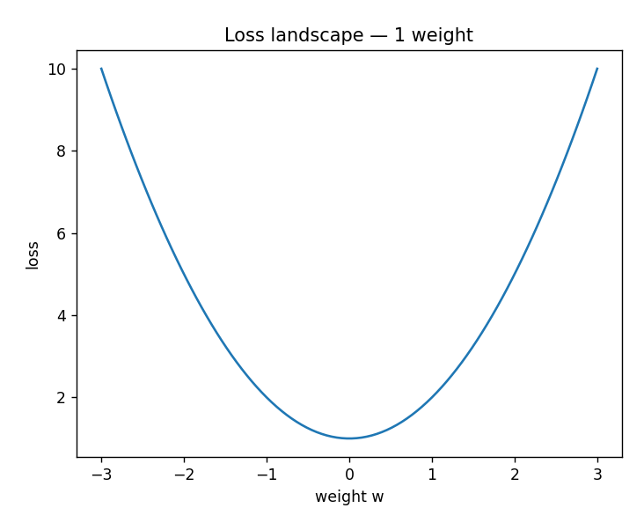

For 2 weights (2 words) the graph would be:
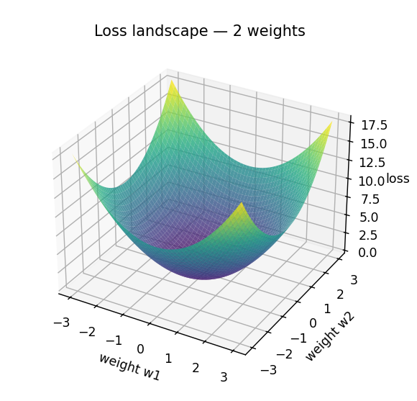

And for 3 weights (3 words) using colors to represent loss:
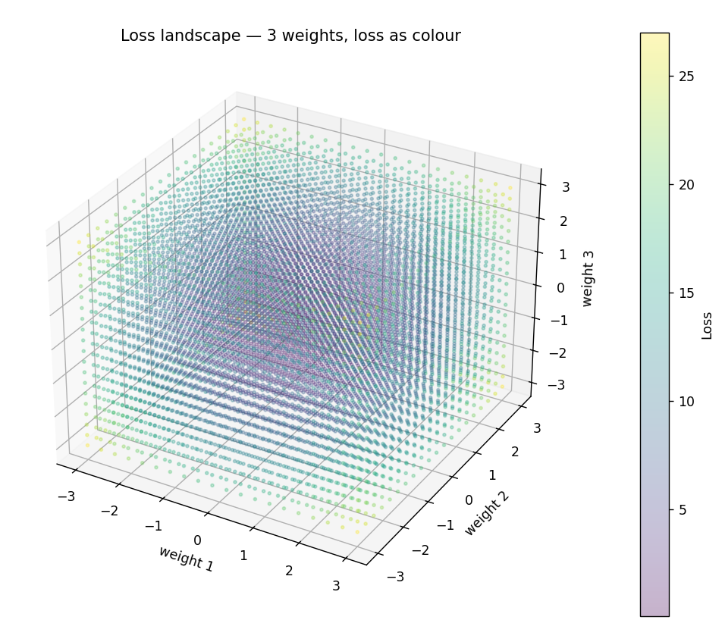

So, each word would add a dimension, therefore any more dimensions become extremely difficult or nearly impossible to visualize graphically.
So, the loss function gives us a point in a complex space and our goal is to go as close to 0 as possible for every axis, but we have no way of knowing in which direction to go.
So how will we solve this? We will use the gradient which at any point in the loss landscape, no matter how many dimensions, the gradient tells us which direction moves the loss up or down and how steeply the loss changes in that direction.

Let’s take the 1 weight example:
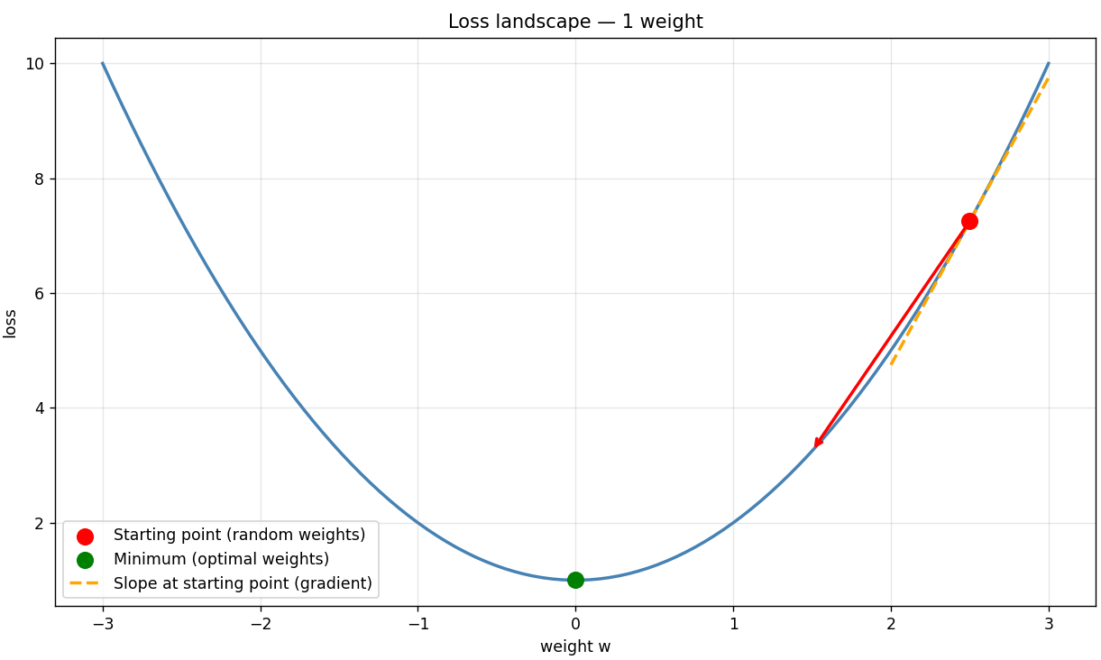
In order to find the minimum, we would find the derivative and set it to 0, meaning for instance if we have:
$$L\left(w\right)=w^{2}+1$$
Then the slope would be:
$$\frac{dL}{dw}=2w$$
Therefore, the minimum:
$$2w=0⟹w=0$$

If we were to do this for 3 dimensions:
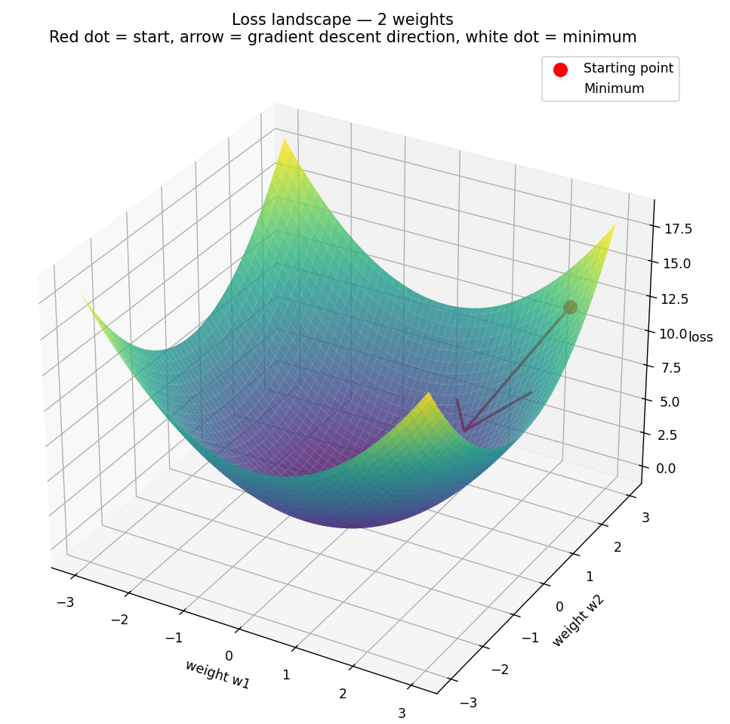
Since we have 2 variables, we have to do patrial integration, meaning we differentiate one variable while keeping the other constant. So, for this shape:
$$L\left(w_{1},w_{2}\right)=w_{1}^{2}+w_{2}^{2}+1$$
We take the partial derivative for each variable:
$$\frac{∂L}{∂w_{1}}=2w_{1}$$
$$2w_{1}=0⟹{ w}_{1}=0$$

$$\frac{∂L}{∂w_{2}}=2w_{2}$$
$$2w_{2}=0⟹{ w}_{2}=0$$
So, the minimum would be (0,0). Both of these were simple symmetrical functions, however in a real dataset the minimum could be anywhere. If we were to also calculate a real dataset with thousands emails, we would have hundreds of thousands of weights (hence dimensions) therefore hundreds of thousands of equations which even for modern computers is nearly impossible to work with. This is why we our loss function from earlier comes in, which is directed to the whole dataset rather than individual variables, therefore we will differentiate it directly and use the result to iteratively step toward the minimum, this is called “gradient descent”:
So, we have our loss function:
$$L=-\frac{1}{n}\sum_{i=1}^{n}{\left[y_{i}\log{{\hat{y}}_{i}}+\left(1-y_{i}\right)\log\left(1-{\hat{y}}_{i}\right)\right]}$$
We will first find the derivative for 1 email and then apply it to all, so the loss for a single email is:
$$L=-\left[y\log{\hat{y}}+\left(1-y\right)\log\left(1-\hat{y}\right)\right]$$

And we want to find $\frac{∂L}{∂w}$, meaning how much the loss changes when we nudge a single weight.
Since $\hat{y}=\frac{1}{1+e^{-z}}$ and “w” is buried inside “z” we will use the chain rule, hence:
$$\frac{∂L}{∂w}=\frac{∂L}{∂\hat{y}}×\frac{∂\hat{y}}{∂z}×\frac{∂z}{∂w}$$
Therefore for $\frac{∂z}{∂w}$, since “z” is:
$$z=w×x+b$$
$$\frac{∂z}{∂w}=x$$
Then for $\frac{∂\hat{y}}{∂z}$:
$$\hat{y}=\frac{1}{1+e^{-z}}={\left(1+e^{-z}\right)}^{-1}$$
So, we apply the chain rule again:
$$\frac{d}{du}u^{-1}=-u^{2}=-\frac{1}{{\left(1+e^{-z}\right)}^{2}}$$
$$\frac{d}{dz}\left(1+e^{-z}\right)={-e}^{-z}$$
$$\frac{d\hat{y}}{dz}=-\frac{1}{{\left(1+e^{-z}\right)}^{2}}×{-e}^{-z}=-\frac{{-e}^{-z}}{{\left(1+e^{-z}\right)}^{2}}$$

If we split the function into two parts:
$$\frac{1}{1+e^{-z}}×\frac{e^{-z}}{1+e^{-z}}$$

We can simplify the first part since it is equal to $\hat{y}$ and the equation becomes:
$$\hat{y}×\frac{e^{-z}}{1+e^{-z}}$$

And for the second part we can split the fraction:
$$\frac{e^{-z}}{1+e^{-z}}=\frac{1+e^{-z}-1}{1+e^{-z}}=1-\frac{1}{1+e^{-z}}$$

Which is just equal to $1-\hat{y}$, hence:
$$\frac{∂\hat{y}}{∂z}=\hat{y}\left(1-\hat{y}\right)$$
Then finally for $\frac{∂L}{∂\hat{y}}$we will split the terms and differentiate them:
$$\frac{∂}{∂\hat{y}}-y\log{\hat{y}}=-\frac{y}{\hat{y}}$$
$$\frac{∂}{∂\hat{y}}-\left(1-y\right)\log\left(1-\hat{y}\right)=\frac{1-y}{1-\hat{y}}$$
So:
$$\frac{∂L}{∂\hat{y}}=-\frac{y}{\hat{y}}+\frac{1-y}{1-\hat{y}}$$

Therefore:
$$\frac{∂L}{∂w}=\left[-\frac{y}{\hat{y}}+\frac{1-y}{1-\hat{y}}\right]×\hat{y}\left(1-\hat{y}\right)×x$$

If we expand brackets we’re left with:
$$(-y+y\hat{y}+\hat{y}-y\hat{y})×x$$

Therefore:
$$\frac{∂L}{∂w}=\left(\hat{y}-y\right)×x$$

This is for 1 email, if we are to average it across all emails:
$$\frac{∂L}{∂w}=\frac{1}{n}\sum_{i=1}^{n}{\left({\hat{y}}_{i}-y_{i}\right)×x_{i}}$$

Now we have differentiated for “w”. For the bias “b” we will do the same process but since z is:
$$z=w×x+b$$
$$\frac{∂z}{∂b}=1$$

Everything else remains the same, so finally we have:
$$w→w-\left(\frac{1}{n}\sum_{i=1}^{n}{\left({\hat{y}}_{i}-y_{i}\right)×x_{i}}\right)$$
$$b→b-\left(\frac{1}{n}\sum_{i=1}^{n}{\left({\hat{y}}_{i}-y_{i}\right)}\right)$$

Finally, we will add 1 more parameter which will adjust the speed of our training called “learning rate” as “α”.

$$w→w-α\left(\frac{1}{n}\sum_{i=1}^{n}{\left({\hat{y}}_{i}-y_{i}\right)×x_{i}}\right)$$
$$b→b-α\left(\frac{1}{n}\sum_{i=1}^{n}{\left({\hat{y}}_{i}-y_{i}\right)}\right)$$
Which is fully written out is:
$$w→w-α\left(\frac{1}{n}\sum_{i=1}^{n}{\left(\frac{1}{1+e^{-\left(w_{i}×x_{i}+b\right)}}-y_{i}\right)×x_{i}}\right)$$
$$b→b-α\left(\frac{1}{n}\sum_{i=1}^{n}{\left(\frac{1}{1+e^{-\left(w_{i}×x_{i}+b\right)}}-y_{i}\right)}\right)$$
Where:
- $w_{i}$: weight for specific word of an email
- $x_{i}$: the count of word $w_{i}$ being evaluated in a single email
- $y_{i}$: the true label of the email, 1 for spam, 0 for ham
- $b$: bias of the dataset
- $n$: total amount of emails in the dataset
- $α$: learning rate (controls the amount the model will move during training)

These are our final training formulas which we will apply to the dataset.

